Assignment 3

Name: Suryansh Sandeep Kumar Singh

Div.: B

Roll No: S1951122

PRN: 72018560C

Problem Statement: -

Write a recursive program to find the solution of placing n queens on chessboard so that no two queens attack each other using Backtracking

Code:

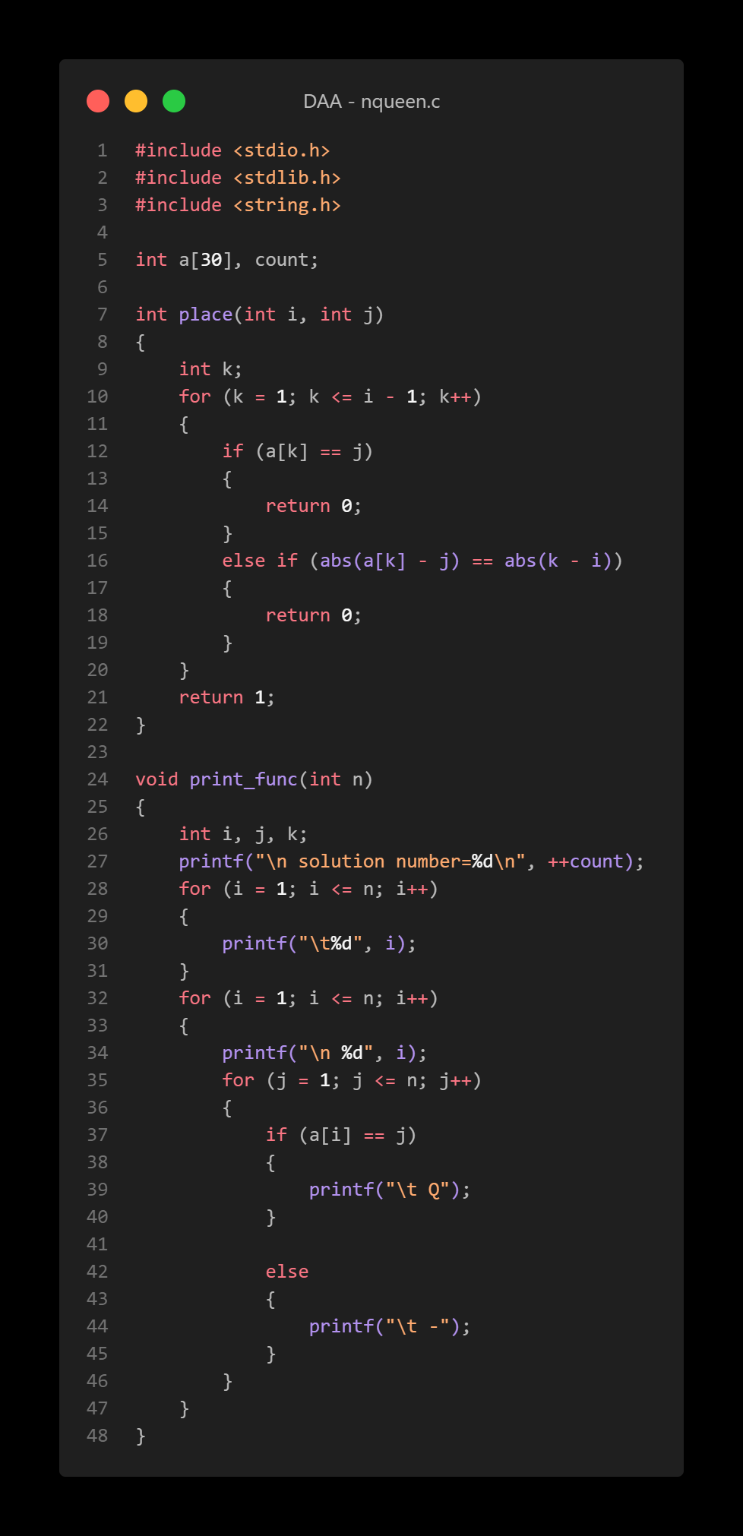

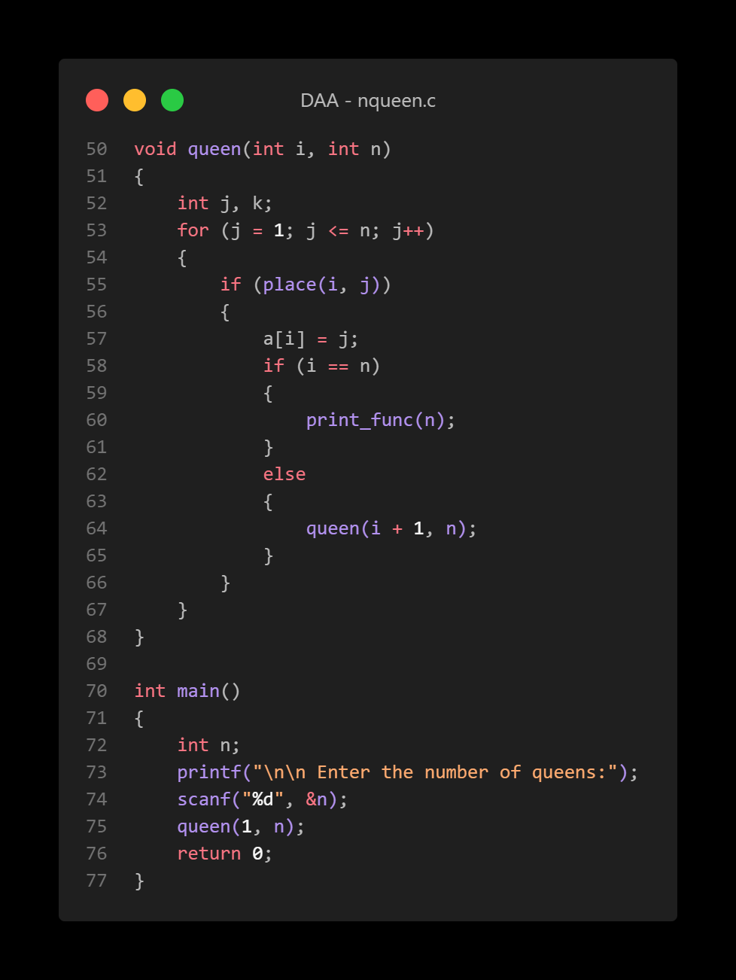

Output:

